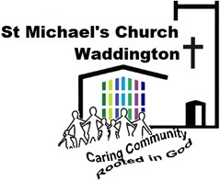
Rector: Revd Annabel Barber MA
(revannabelbarber@gmail.com 01522 721306)
Role description: Holiday Club Helper

- Your work will include these roles
- To plan and co-ordinate the Holiday Club activities for children aged 5 -11 years old.
- To exercise active pastoral concern
- To represent the needs and views of children to the Parochial Church Council or, where appropriate, enable them to do this for themselves.
- To maintain a link with parents and carers
- To work in accordance with the church’s policy on safeguarding.
- To undertake any other work that has been agreed and is seen to be appropriate

- Skills, knowledge and experience required

Workers with children should have a commitment to:
- Treat them with respect.
- Recognise and respect their abilities and potential for development. 
- Promote their rights to make their own decisions and choices, unless it is unsafe.
- Ensure their welfare and safety.
- The promotion of social justice, social responsibility and respect for others.
- Confidentiality, never passing on personal information, except to the person you are responsible, unless there are safeguarding issues of concern. These must always be reported.

The ability to
- Relate informally to children.
- Complete of church safeguarding course
- To initiate informal conversations with young people.
- To lead through prepared Bible study material and activities with children.

- Other Requirements
- Current DBS Enhanced Disclosure that meets our minimum requirements
- Current church membership

- Other information relevant to this job description
- St Michael’s safeguarding policy
- St Michael’s Mission statement

Responsible to:
The Parish Priest Revd. Annabel Barber (or her named representative) and through them to the Parochial Church Council.

Adopted by St Michael’s PCC…………………………………..( Date)

Signed………………………………………………PCC Chair

